|  |  |  |  |
| --- | --- | --- | --- |
| a | b | c | salida |
| 0 | 0 | 0 | 0 |
| 0 | 0 | 1 | 1 |
| 0 | 1 | 0 | 0 |
| 0 | 1 | 1 | 1 |
| 1 | 0 | 0 | 0 |
| 1 | 0 | 1 | 0 |
| 1 | 1 | 0 | 0 |
| 1 | 1 | 1 | 1 |

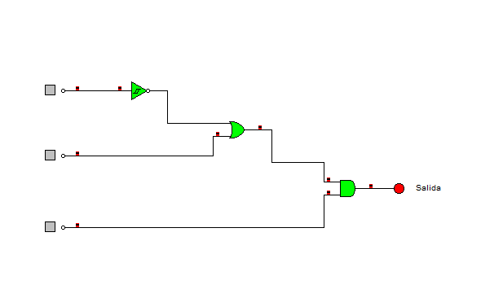

**Salida= (á+b)c**

**Salida= á*b*c+a*b*c**